Practical-3: Advanced Programs using User Defined Function
1) | Factorial using function and recursive function.
 | Program :-
#include<stdio.h>

void main(){
printf("Enter value: ");
int n,fact=1;
scanf("%d",&n);
fact=factorial(n);
printf("Factorial of %d: %d",n,fact);
}

int factorial(int n){
if(n!=0){
return n*factorial(n-1);
}
else{
return 1;
}
}

 | Output :-
 | 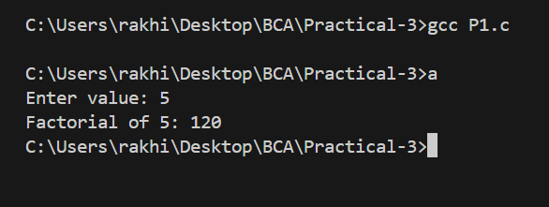
2) | Pass an array in function to print array.  Program:-
#include<stdio.h>
void printArr(int [],int);
void main(){
printf("Enter array size: ");
int n;
scanf("%d",&n);
int a[n];
for (int i = 0; i < n; i++)
{
printf("Enter value for index %d: ",i);
scanf("%d",&a[i]);
}
printArr(a,n);
}

void printArr(int arr[],int size){
printf("\nValues: \n");
for (int i = 0; i < size; i++)
{
printf("\t%d\n",arr[i]);
}
}

Output:-
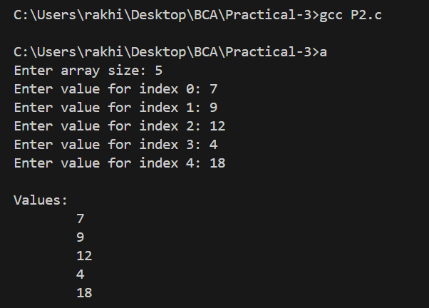
3) | Find power of any number using recursion.  Program:-  #include<stdio.h>  int calcPower(int,int);  void main(){  int base,power,result;  printf("Enter base: ");  scanf("%d",&base);  printf("Enter power: ");  scanf("%d",&power);  result=calcPower(base,power);  printf("Base: %d\nPower: %d\nResult: %d",base,power,result);  }  int calcPower(int base, int power){  if (power==0)  return 1;  else  return base*calcPower(base,power-1);  }  Output:-  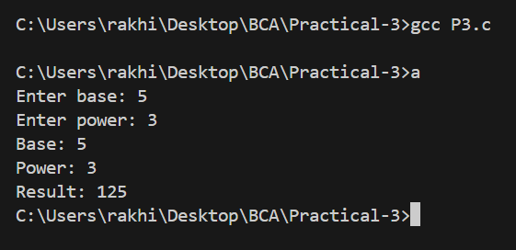
4) | Scan a character string passed as an argument and convert all lowercase string to uppercase string.  Program:-  #include<stdio.h>  void toUpper(char []);  void main(){  char s[50];  printf("Enter string: ");  gets(s);  printf("Original String: %s\n",s);  toUpper(s);  printf("Uppercase String: %s",s);  }  void toUpper(char s[]){  for (int i = 0; s[i] != '\0'; i++)  {  if (s[i]>='a' && s[i]<='z')  {  s[i]=s[i]-32;  }  }  }  Output:-  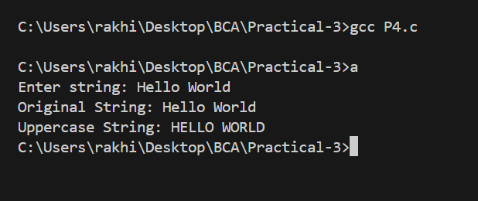
5) | Swap elements of two integer arrays using user define function.  Program:-  #include<stdio.h>  void swap(int *,int *,int);  void main(){  int n;  printf("Enter size for the arrays: ");  scanf("%d",&n);  int a[n],b[n];  printf("Enter elements for first array\n");  for (int i = 0; i < n; i++)  {  printf("Enter value for index %d: ",i);  scanf("%d",&a[i]);  }  printf("Enter elements for second array\n");  for (int i = 0; i < n; i++)  {  printf("Enter value for index %d: ",i);  scanf("%d",&b[i]);  }  printf("Before swap values\n\tA\tB\n\n");  for (int i = 0; i < n; i++)  {  printf("\t%d\t%d\n",a[i],b[i]);  }  swap(a,b,n);  printf("After swap values\n\tA\tB\n\n");  for (int i = 0; i < n; i++)  {  printf("\t%d\t%d\n",a[i],b[i]);  }  }  void swap(int a[],int b[],int n){  for (int i = 0; i < n; i++)  {  int temp=a[i];  a[i]=b[i];  b[i]=temp;  }  }  Output:-  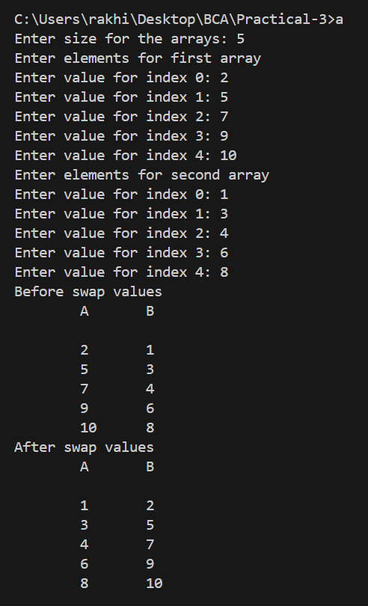

6) Find reverse of any number using recursion.
Program:-

#include<stdio.h>
int reverse(int,int);

void main(){
int n;
printf("Enter value: ");
scanf("%d",&n);
int x=reverse(n,0);
printf("Original number: %d\nReverse number: %d",n,x);
}

int reverse(int n,int rev){
if (n==0)
{
return rev;
}
rev=rev*10+(n%10);
return reverse(n/10,rev);
}

Output:-

